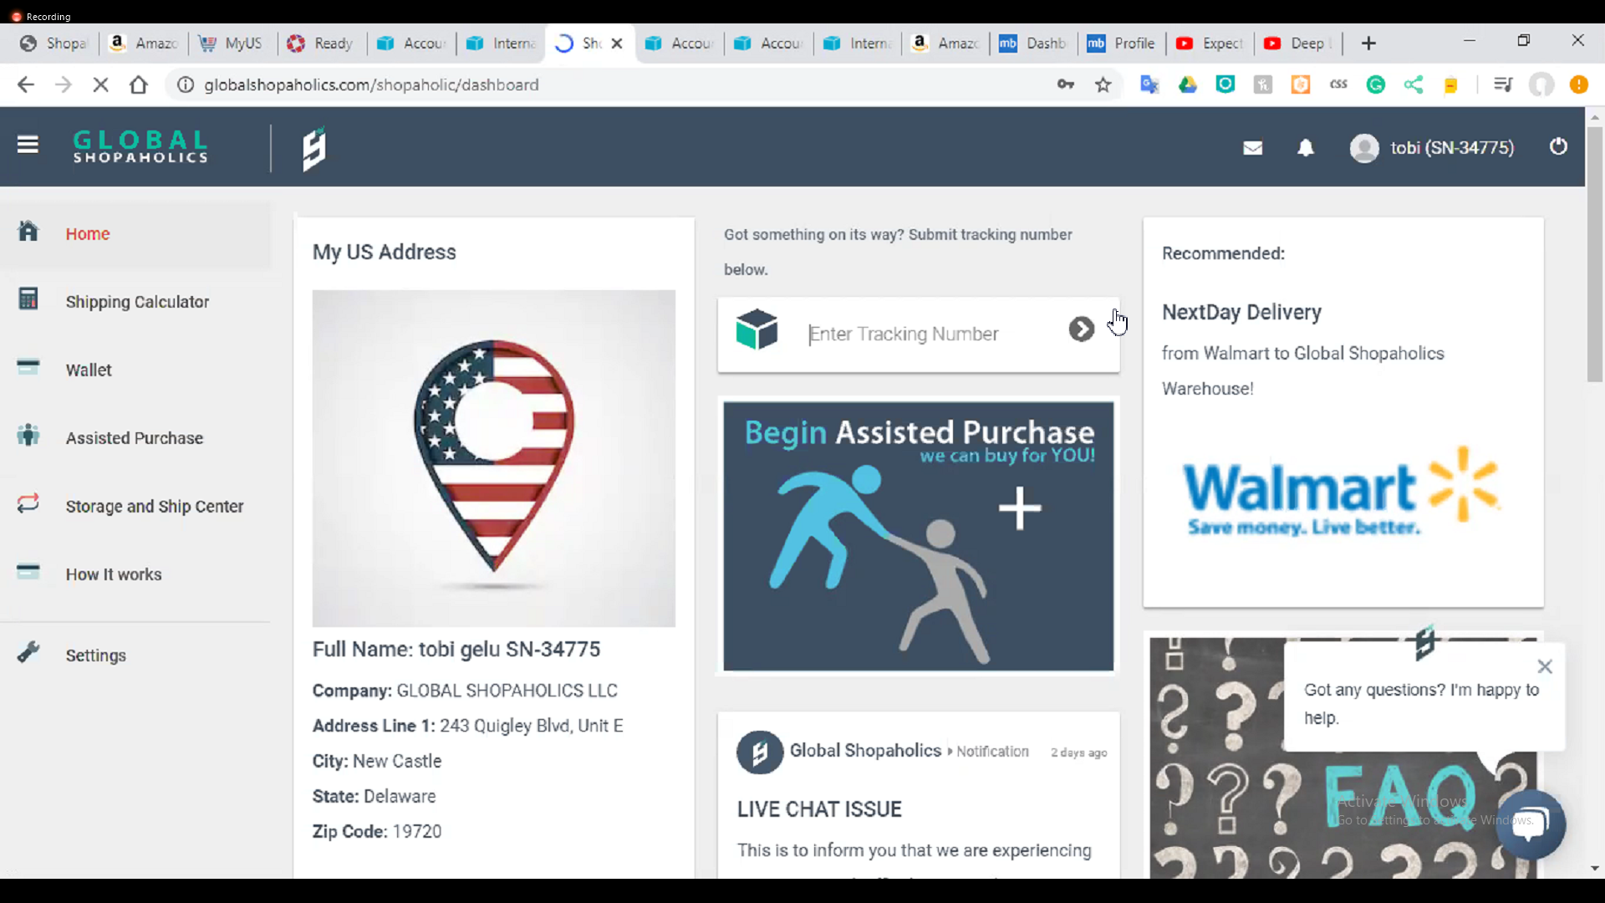

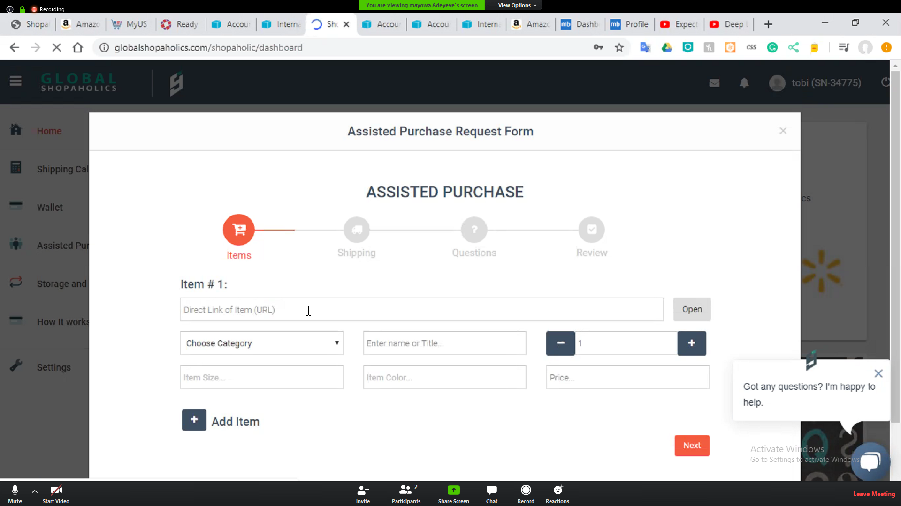

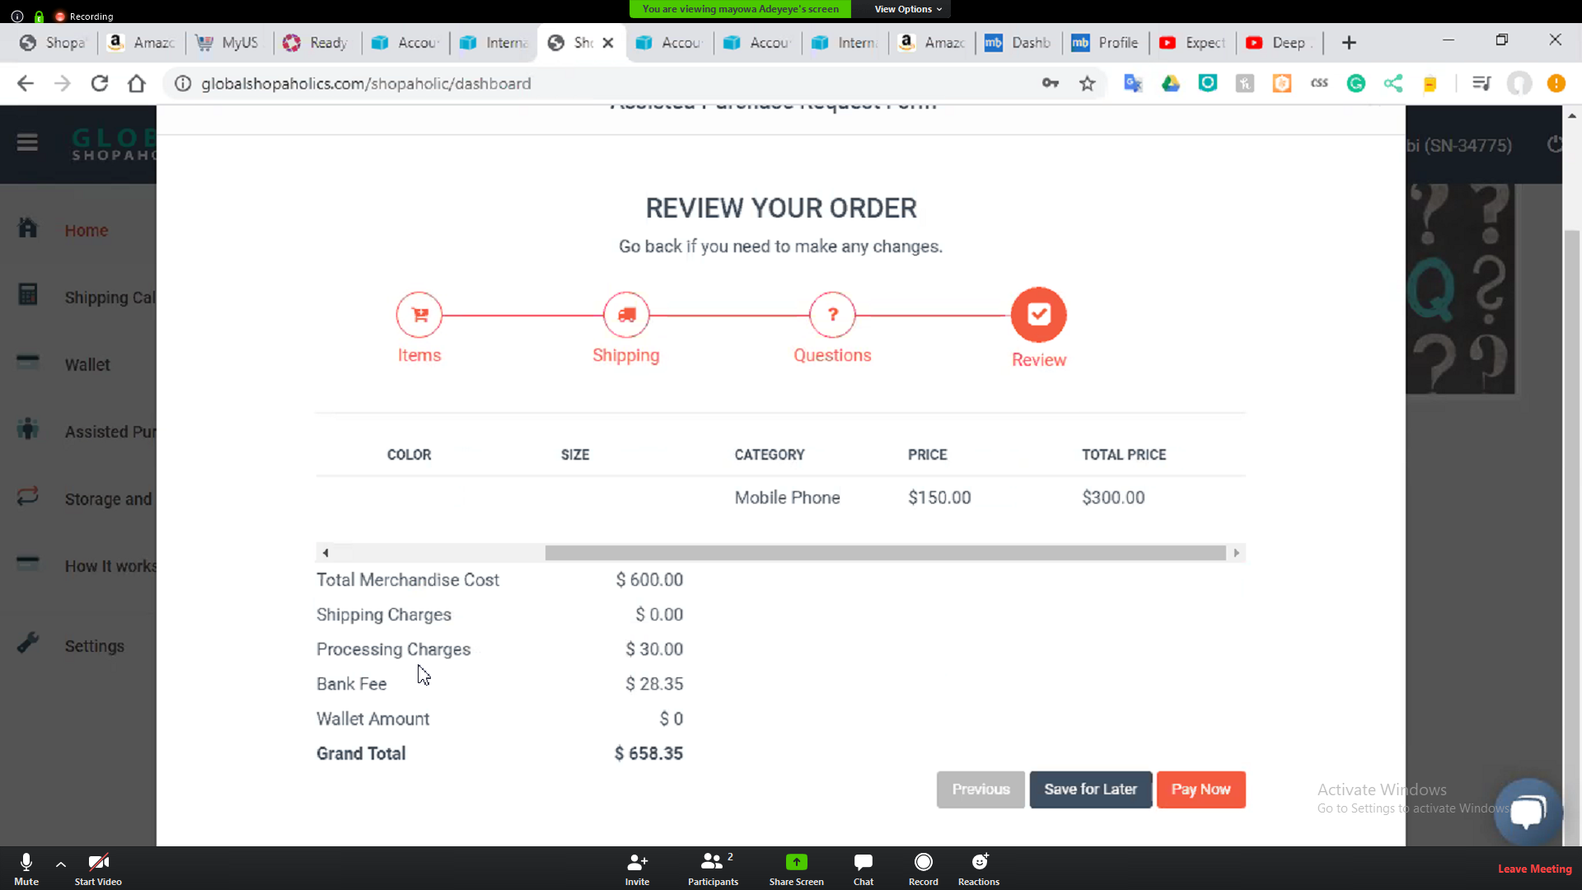

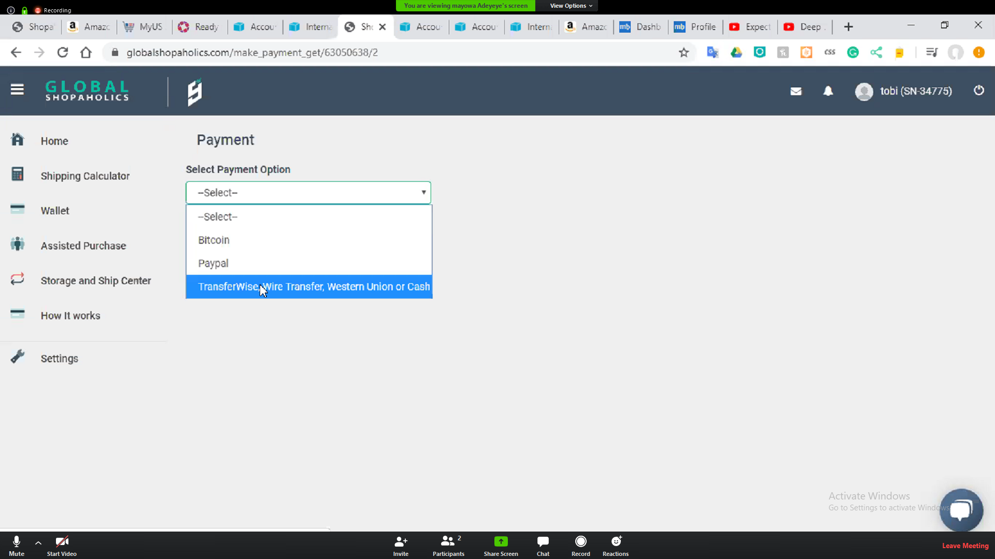

for the pay4me

1. let the price of items sum up based on the price in the link submited by user

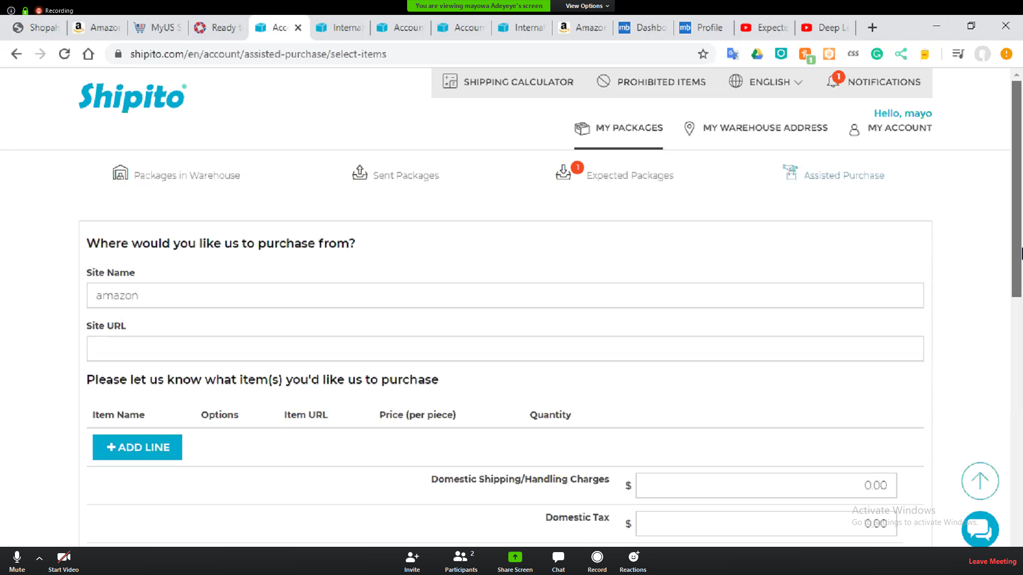

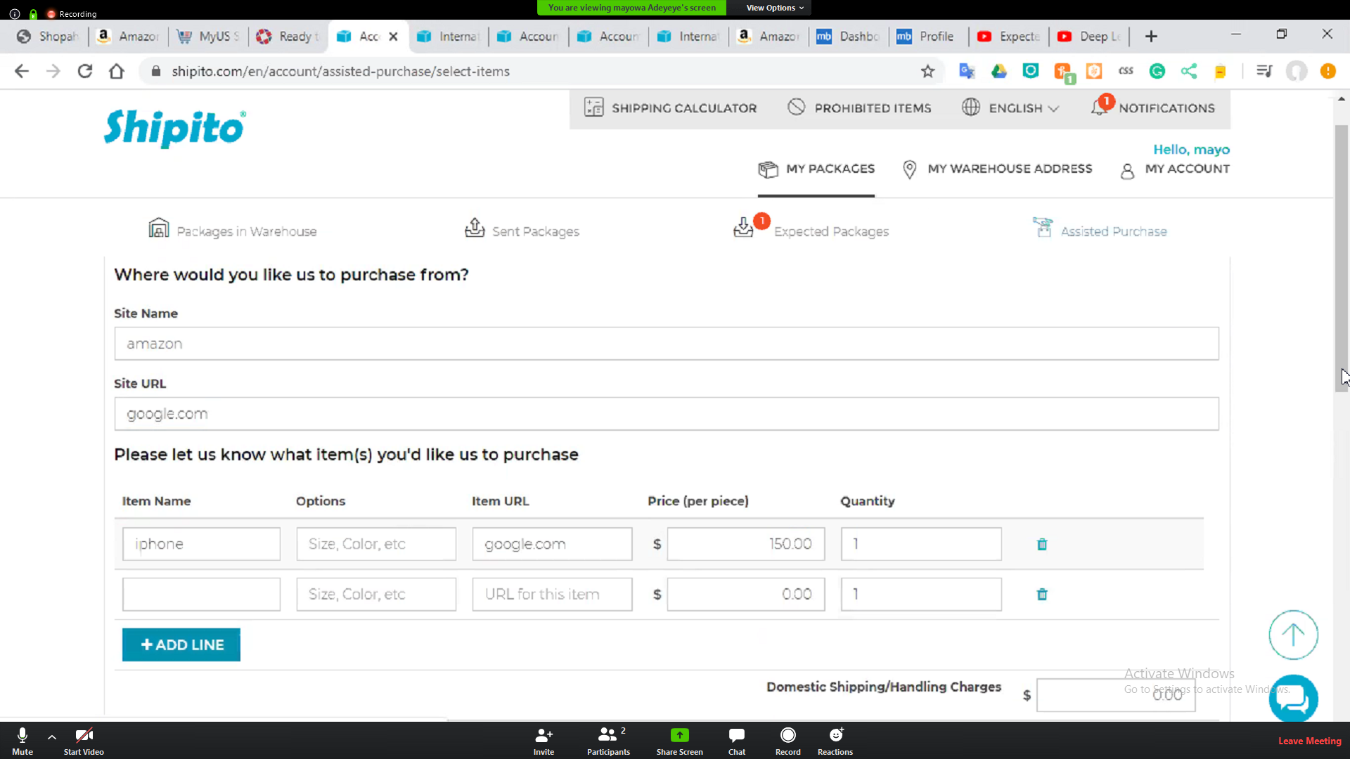

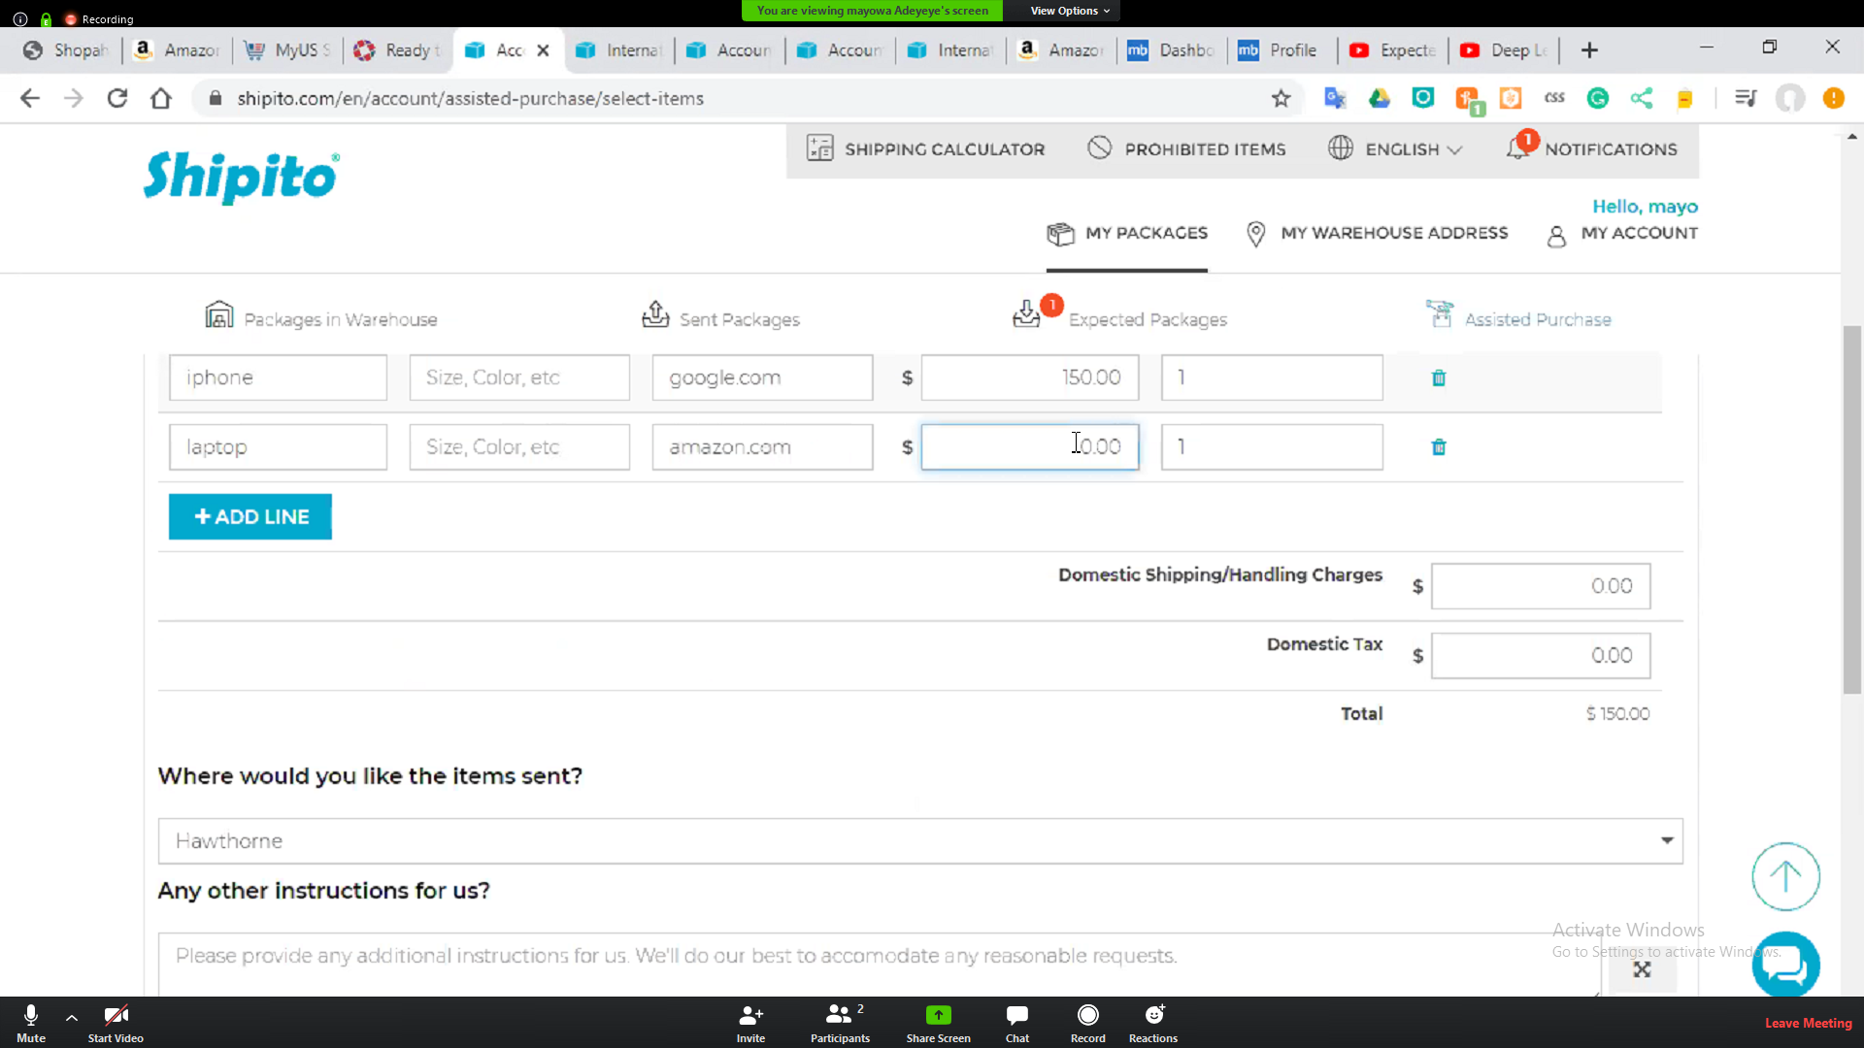

2. user should be abe to save it in case they plan to come back to it.

3. user shld have option to checkout from that page after adding item just as u plan it b4.

4. during checkout add service charge of $10 or 8% which ever one is higher to the initial total (usd10 minium.

5. checkout shild be via paypal, bitcoin or Credit card

6. we also need to have payment record for user and admin

Expected item

I think this should go to the backend.

Warehouse

lets have 3 STATUS here which are :

Received: for item that we received

shipped: for item that we processed for shipment

deliverd : for delivered item to user

shipmyitems

select from the warehouse received package.

so when u select 2 package u pay $2 consolidation and continue to increase by $2 when u choose more package in the warehouse.

we also have flat rate for consolidation which is $8. user pay whichever one is lesser.

This is where we need to dhl, fedex ups

This is the complex part i guess. we need to implement a calculator here

check www.ship7.com calculator for sample

